### **UNIT 4.2**

### **THE COMPUTER SYSTEMS AND SOFTWARE**

**TUTOR NAME: MS. FATHIMA**

**SUBMITTED BY FATIMA EJAZ BARRI**

Contents

**UNIT 4.2** 1

**THE COMPUTER SYSTEMS AND SOFTWARE** 1

LO1- 6

1.1 Describe the components of different computer system 6

Computer system 6

Central processing unit: 6

Input unit: 7

Output unit: 7

Storage unit: 7

Secondary Storage: 7

Arithmetic Logical Unit: 7

Control Unit: 7

Memory Unit: 7

Random Access Memory (RAM): 8

Types of RAM 8

Dynamic Random Access Memory 8

Static Random Access Memory 8

Read-Only Memory (ROM): 8

Types of ROM 8

Programmable Read Only Memory (PROM) 9

Erasable programmable read only memory (EPROM) 9

Electrically erasable programmable read only memory (EEPROM) 9

1.2 Analyse networking infrastructures 9

Computer network: 9

Local area network (LAN): 10

Uses of MAN 11

Wide area network (WAN) 11

Examples of wide area network: 11

Advantages of wide area network 12

Disadvantages of wide area network 12

Personal area network (PAN) 12

Wired personal area network 13

Wireless personal area network 13

Body area network: 13

Offline network: 13

Small home office: 14

Network infrastructure: 14

Networking hardware: 14

Networking software: 14

Network services: 14

Network devices: 14

Hub 14

Switch 15

Router 15

Bridge 16

Gateway 16

Modem 16

Repeater 16

Access point 16

1.3 Assess the function of components within a chosen computer system. 17

Components of computer system 17

Computer hardware: 17

Computer software: 17

Liver ware: 17

Super computer: 17

1.4 evaluate peripheral devices to meet different purposes 18

Input device: 18

Examples of input devices: 18

Output deceive 19

2.1 evaluate different operating systems explaining their role in managing resources 19

An operating system 19

2.2 critically assess the use of the different software applications to meet specific purposes 21

System software 21

Device drivers 22

Firmware 22

Programming language translators 22

2.3 assess the use of web applications to enhance user experience. 25

Web application: 25

Static web application 25

Dynamic web application 26

Online or e-commerce 26

Portal web app 26

Animated web app 26

2.4 assess the use of mobile applications to enhance user experience 27

Mobile applications: 27

Native apps: 27

Example of the native apps: 28

Mobile web apps: 28

Examples of mobile web apps: 28

Hybrid apps: 29

Examples of hybrid apps: 29

Progressive web apps: 29

What is big data? 31

**DATA:** 31

Types of Big Data 32

Structured 32

Unstructured: 33

Semi-structured 34

Bibliography: 35

# LO1-

# 1.1 Describe the components of different computer system

**Computer system**

The computer system has one or more data inputs. Then this data will be processed in some way. The result of the processing is sent to an output or it can be processed until there is some event that cause it to be generated.

Central processing unit (CPU): It is an element of the computer that interprets and executes the computer's hardware and software commands. Normally, it is part of the computer's motherboard. CPUs used to consist of individual components and several small integrated circuits, but due to new development methods, the CPU is now referred to as a microprocessor; these have been merged on one or more circuit boards.

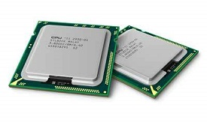

Input unit: These are hardware devices, as the name implies, that allow the input of information into a PC. There are many such devices, such as the keyboard, to the most specialized devices, such as barcode readers.

Output unit: These are hardware devices which enable the output of data from a computer. Some machines temporarily retain the data (such as in a buffer/memory printer), while others deliver permanent output in the form of a hard copy (such as a printer producing output on paper). There is a third type of output system that is used in combination with sensor input devices to monitor processes.

Storage unit: For storing, porting or deleting files.

Secondary Storage: The information is stored temporarily in the RAM when a user loads data into a computer. Secondary storage device ensure the permanent storage of data so that it can be reused at a later date.

Arithmetic Logical Unit: A part of a computer that does all of the computer's arithmetic computing.

Control Unit: control unit controls the roll of processor and tells the computer’s components and input/output devices how to react to certain instruction of a program.

Memory Unit: computer memory is any physical device that can temporarily store information on a permanent basic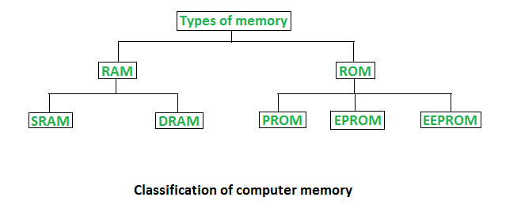. Example, RAM

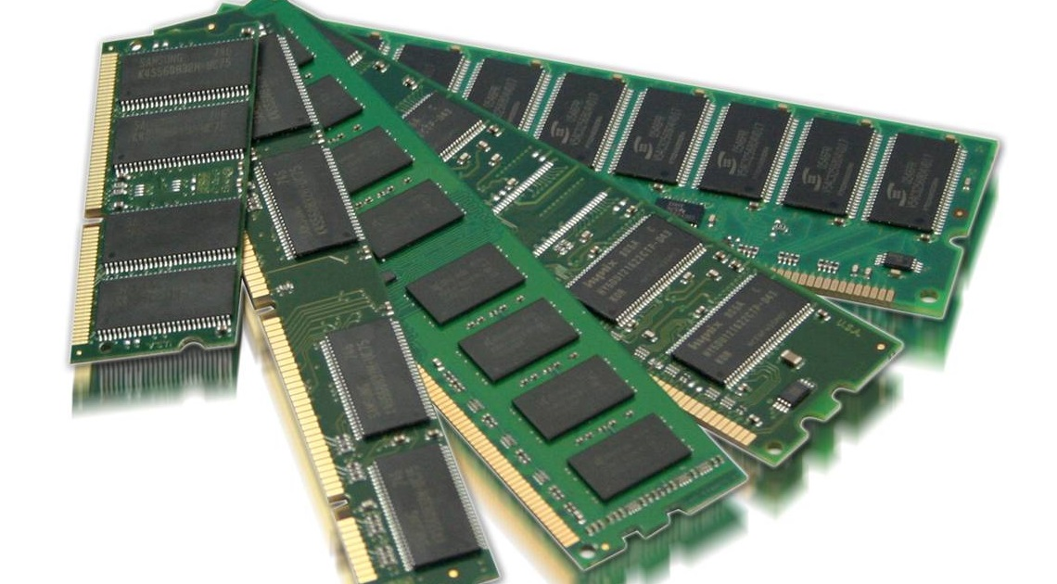Random Access Memory (RAM): It is an internal chip where information is temporarily stored when applications are running. You can write down this memory and read from it. Data is lost when the computer's is switched off, it is often referred to as a volatile memory. RAM stores the current data, files, or part of the operating system in use.

## Types of RAM

* Dynamic Random Access Memory
* Static Random Access Memory

## DRAM

* Constructed of tiny electric leak-leak capacitors.
* Requires a charge to maintain its data every milliseconds.
* Low-cost.
* Less than SRAM
* Multiple bits can be stored per chip.
* Less fuel is used.

## SRAM

* Their contents are started until system is on
* Expensive
* Faster than DRAM
* Cannot store of a lot bit per chip.
* Uses power.
* Gives more heat.
* Used for a cache

Read-Only Memory (ROM): is a memory used to store information that needs to be permanent. It is often used to contain, for example, configuration data for a computer system. These chips cannot be altered and can only be read from (hence their name).

## Types of ROM

There are three main ROM types.

* PROM
* EPROM
* EEPROM

## Programmable Read Only Memory (PROM)

PROM is ready for the memory chip that a user can reach only once. The difference is that during the production process, ROM is programmed; PROM is produced as a bank memory. The user buys a PROM; after making it, the user needs a special device called a PROM programmed by “Blowing” the fuses, which is an irreversible process.

## Erasable programmable read only memory (EPROM)

EPROM programming memory which stores it data even if the power is turned off. The data can be retrained once the system is on without any loss.

## Electrically erasable programmable read only memory (EEPROM)

This kind of read only memory is used in microcontrollers, smart cards, etc. it is there to store small amount of relative data.

# 1.2 Analyse networking infrastructures

## Computer network:

#### A group of computers linked to one another is called a network of computers. This ranges from basic school/home networks of only a few computers to large networks such as the Internet, allowing any computer connected to it to communicate effectively with any other connected computer.

#### Computer Network Types

#### Types of computer network

Many types of networks appear, including:

## Local area network (LAN):

A typical LAN consists of a number of computers and devices that are connected to hubs or switches (for example, printers). Usually, these systems are within one building, or certainly not geographically very far from each other.

#### Metropolitan area network (MAN)

For a larger area than LAN but smaller than WAN. 3G mobile networks are the fundamental use of MAN.

## Uses of MAN

* Mobile towers
* Offices
* Schools
* Hospitals
* Airports

## Wide area network (WAN)

WANs are used where computers or networks are geographically located a long distance from each other. A number of LANs are joined together, then they can form a WAN. The internet and the network of ATMs used by banks include the most common examples of WAN.

## Examples of wide area network:

* Internet
* International banks
* Private school networks
* Government offices

## Advantages of wide area network

## The same services and resources (such as printers, scanners, and internet access) can be accessed by all computers from anywhere within the range.

## Safer and more flexible.

## It's easy to add new computers and devices.

## Low expenses

## Disadvantages of wide area network

## Security can be a big problem because if it can pick up a signal, anyone with a WLAN-enabled laptop can access a network; complicated data encryption techniques must therefore be adopted.

## Interference issues may occur that may affect the signals.

## The rate of information transfer is slower than wired LAN

## Personal area network (PAN)

This kind of network is established within a house and used to connect smaller devices. For example, a computer connected to another computer, speaker, printer, phone, headphone, etc.

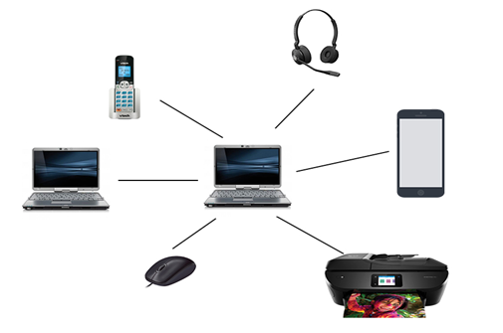

## Wired personal area network

Using a piece of hardware to connect devices with each other.

## Wireless personal area network

Short distant network commonly used in houses and offices to connect normal daily use devices like printers, mouse, phone, fax machine, etc.

Examples of personal area network:

## Body area network:

Network used for small devices, which are on or around your body. For example, smart watches, vital signs, etc.

## Offline network:

Network to create connectivity with a room like an office to connect devices without Wi-Fi i.e. Bluetooth

## Small home office:

Using a virtual private network which connect various devices to internet also a corporate network.

## Network infrastructure:

The network infrastructure is the hardware and software resources of an entire network that enables the connection, operation and management of an enterprise network. It provides the commutation path and services for users, processes, application services and external networks.

## Networking hardware:

* Routers
* Switches
* LAN cards
* Wireless routers
* Cables

## Networking software:

* Network operations and management
* Operating systems
* Firewall
* Network security applications

## Network services:

* T-1 line
* DSL
* Satellite
* Wireless protocols
* IP addressing

## Network devices:

Network devices and networking hardware are physical devices that are required to communicate and interact with hardware on a computer network.

## Types of network devices:

## Hub

## Hubs are hardware devices that can have a number of connected devices or computers. They are often used to connect a number of devices together to form a LAN, such as a star network. The main task is to take any data packet received at one of its ports (this is a group of data being transmitted) and broadcast it to every computer on the network. This essentially implies that it is not a very secure or efficient data distribution method to use a hub.

## Switch

## Switches are similar to hubs, but in the way that they distribute data packets, they are much more effective. They connect a number of devices or computers together to form a LAN, as with hubs.

## Router

## Routers allow the routing of data packets between different networks, such as joining a LAN to a WAN. An internet cable connecting to computers and other devices on the LAN would typically have a router plugged into it.

## Bridge

## Bridge is a tool that connects one LAN to another LAN with the same protocol (communication rules). They are often used to link various parts of a LAN together so that they can function as a single LAN.

## Gateway

## A gateway is a network point which acts as an entry to another network. All networks will have boundaries so that all communication is carried out using devices such as switches or routers within the network. It needs to use a gateway if a network gateway needs to communicate outside its network.

## Modem

## is a device that converts the signal of a computer into an analogue signal for transmission over an existing telephone line.

## Repeater

Repeater is a device that amplifies the reachability of a network signals.

## Access point

## A device receives the radio waves via an installed wireless adaptor which allows it to download the information from the data source. This, of course, works in reverse when the device wishes to transmit data over the network.

# 1.3 Assess the function of components within a chosen computer system.

|  |  |
| --- | --- |
| System 1 | System 2 |
| Lenovo G50-80 | Acer predator 15G9-593G |
| Processor intel Core i3 | Processor Intel Core i7 |
| Computer type: laptop | Computer type: laptop |
| 64 bit – operating system | 64 bit operating system |
| X64 – based processor | X64 – based processor |
| Windows 10 home single language | Windows 10 |
| RAM: 4GB | RAM: GDDR5 16GB |
| Intel i3-4005U | Intel Core 17-7700HQ |
| Screen size 15.6 inch | Screen Size: 15.6 inch |
| Hard disk: 2TB | Hard disk: 1Tb+256GB |
| Processor speed: 1.6 GHz | Processor speed: 2.26GHz |
| No touch screen | No touch screen |
| Price: $500 | Price: $1100 |
| 3 battery cells | 4 battery cells |
| RAM size: DDR4 4GB | RAM: GDDR5 16GB |
| No GPU | GPU: VGA 8GB |
| Great for everyday use | Excellent in heavy tasks |

Acer Predator 15G is better as per the scenario than Lenovo G50-80 because Acer has more storage space (1TB+256GB) and the storage type is SSD (solid-state drive) which can help in mass and faster storing, Predator uses a newer processor (intel core I7 with 2.6GHz) which increases workflow and heavy tasks can be done easily and quickly. It has a graphic card (VGA) with the storage space of 8GB which can help in graphic designing any kind of visual representation of customer’s car/ add-ons. Acer also have DDR5 (16GB) which helps in handling large amount of cache data and heavy computing. Acer predator has a quad-core processor which helps in working for long hours without the computer to heat up, which can lead to internal motherboard damage. Overall, in my opinion Acer predator 15G-593G matches the requirements according to the scenario and will help expanding the business and is more networkable as it has many input/output ports.

# 1.4 evaluate peripheral devices to meet different purposes

## Input device:

## These are hardware devices, as the name implies, that allow the input of information into a PC. There are many such devices, such as the keyboard, to the most specialized devices, such as barcode readers.

## Examples of input devices: Keyboard:

A keyboard is the most important input unit. It was usually the only input system in early computing days. A keyboard includes letter and number keys as well as complex functions.

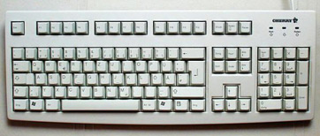

##### Mouse:

An example of a pointing device is the mouse. By moving the mouse around, the user controls the position of a pointer on the screen. Typically, there are two buttons that have different functions: the left button is generally used for menus.

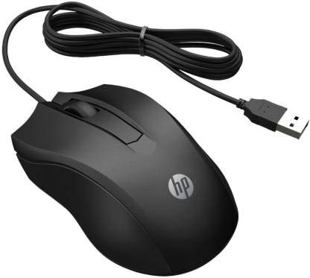

## 

## Output deceive

Some devices temporarily hold data (such as in a buffer/memory printer), while others produce permanent output in the form of a hard copy (such as a printer producing output on paper).

Printers: Printers are used to get a hard copy of a document or a picture. A command is given from a computer device and then it goes to a printer by a USB cable.

There are 2 types of printer:

1. 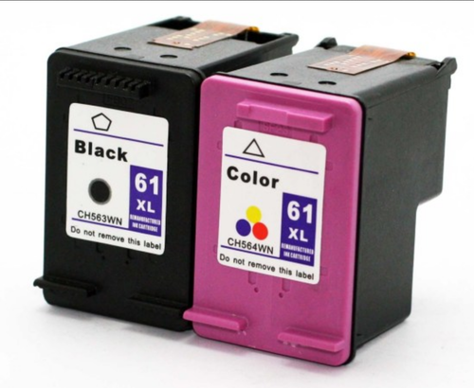Inkjet- uses warm ink, which dries and sticks to the paper. This kind of printers are used in low volume printing and are way cheaper than the other.

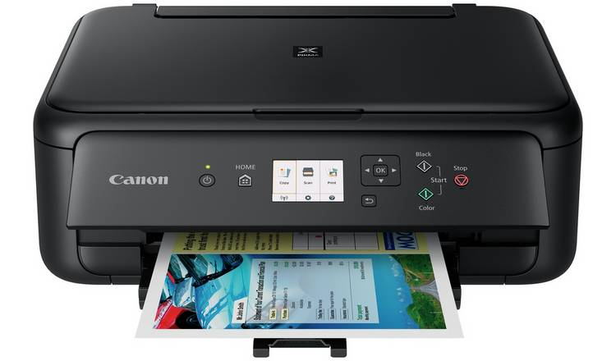

1. LaserJet: Has its cartridge as toner which is in powder form unlike inkjet which has its cartridge containing wet ink. The toner is electronically heated to be printed on. LaserJet printers are usually used in offices, bookstores, making labels, fliers and brochures.

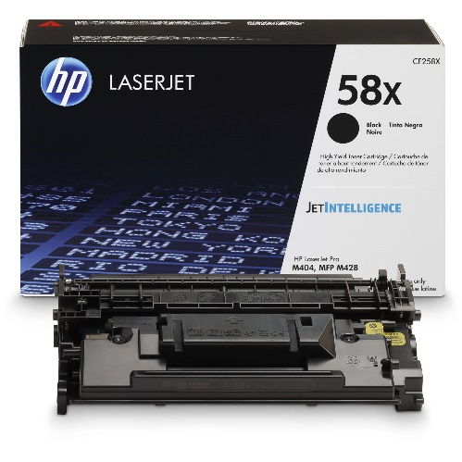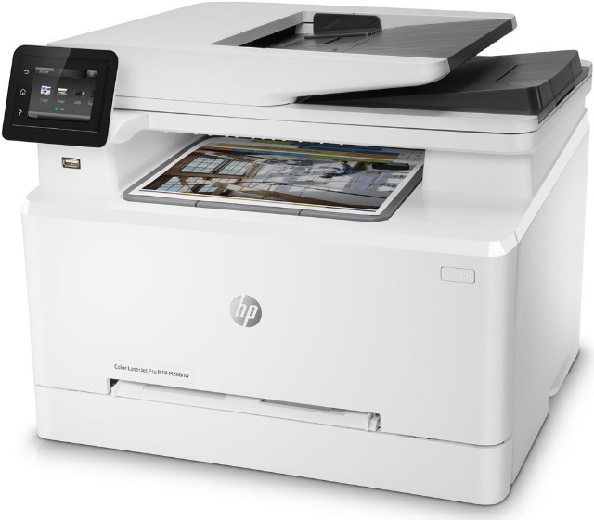

# 2.1 evaluate different operating systems explaining their role in managing resources

## An operating system

The OS is essentially software running in the background of a computer. It manages many of the basic functions.

For applications, an operating system may perform the following services:

* Where multiple programs can run simultaneously. The OS determines which applications should run in which order and how much time should be allowed for each application before switching to another application in a multitasking operating system.
* Internal memory sharing between multiple apps.
* Input and output from and to connected devices are managed.
* It sends messages about the state of service and error that may have occurred to each program or device.
* In order to free the initiating program from this project it can unload batch jobs like printing.
* An operating system can manage the partitioning of a program.

# 2.2 critically assess the use of the different software applications to meet specific purposes

The term “software” refers to the set of instructions for the electronic program or data read by a computer processor to perform a task or operation. The term “hardware” on the other hand, refers to the physical components you can see and touch, such as the hard drive, mouse, and keyboard. Technology can be classified to do what it is intended to do.

There are usually two major software classifications, system software and application software.

## System software

A system software allows the user and the hardware to communicate with each other and connect. Essentially, it is a software to manage the Behaviour of computer hardware to provide the user with basic functionality. Simply put, we can assume that system software is a middle layer between the user and the hardware. For the other software to work in, this computer software authorizes a network or system. That is why system software is very important for the management of the entire computer system once you turn on the computer for the first time, it is the system software that is initialized and loaded into the system memory. In the meantime, the system software is running and is not used by end-users. System software is also known as low-level software.

Examples of common system software are:

* Android
* Macos
* IOS
* Linux
* Ubuntu
* Unix
* Mac OS
* Windows

Operating system: it is system software’s most prominent example. A software collection manages resources and provides general services for other applications running over them. While each operating system is different, most of them provide a graphical user interface that allows a user to access files and folders and perform certain tasks. Each computer, whether it is a desktop, laptop or cell phone, needs an operating system to provide it with the basic functionality. As an operating system ultimately defines how a user communicates with the system, so many users prefer to a use a different operating system for their computer. There are different types of operating system, such as real-time, embedded, distributed, multi-user, single-user, desktop, web etc. when selecting an operating system, it is important to consider the hardware requirements.

## Device drivers

This is a kind of software that regulates different hardware connected to the device. Computer devices that allow a driver to connect to a system include displays, sound cards, printers, mice and hard disk drives. Two types of device drivers are also accessible: kernel device drives and user device driver. Serval system driver examples are:

* BIOS driver
* Motherboard drivers
* Sound card drivers
* USB drivers
* VGA drivers
* Virtual device drivers
* ROM drivers
* Printer drivers

## Firmware

Firmware is the permanent program stored in a memory that is read-only. It is a compilation of permanently stored instructions on a hardware device. This provides important knowledge on how the computer communicates with other hardware. Firmware can be considered as “semi-permanent” as it remains permanent unless it is upgraded with a firmware updater. Few firmware examples are:

* BIOS
* UEFI
* Computer peripherals
* Embedded systems for consumer applications

## Programming language translators

These are mediator programs on which software programs rly to simplify machine-level code by translating high-level languages content. The translator, in addition to simplifying the languages also do the following:

* Assign data storage
* Enlist source code as well as software information
* Provide diagnostic reports
* Correct system errors during runtime
* Interpreter, compiler and assembler are examples of programming language translators.

# 2.3 assess the use of web applications to enhance user experience.

## Web application:

Web application is a remote server used at a large scale like school or offices. A web browser usually accesses web application. It is easier for a developer to make a web application, as the developer does not have to make it for different operating systems. For example, the developer of google chrome have to make two same google chrome servers for window and MAC however, the developers of a single application that runs on chrome will work on both and the developer will have to update the serve and the users of MAC or windows will automatically be updated instead of discretely sending the update to different operating system and their users.

There are six types of the web applications.

* Static web application
* Dynamic web application
* Online store or e-commerce
* Portal web app
* Animated web application

## Static web application

A Static Web Application is any web application that can be delivered directly to the browser of an end user without altering HTML, CSS, or JavaScript content from the server side.

## Dynamic web application

## In real time, a dynamic web application generates the pages/data, as per the request, a corresponding response will trigger from the server’s end and reach the client end (your end). The client side code will take action as it is meant to, depending on the response.

## Online or e-commerce

## A business model that allows companies and individuals to buy and sell things over the internet is electronic commerce or e-commerce (sometimes written as e-commerce). In all four of the following major market segments, e-commerce operates: Business to business. Enterprise to consumer.

## Portal web app

## By portal, we refer to a type of application in which we access the service of its sections or categories via a home page. These programs can include a number of things: forums, discussions, areas of email apps accessible by registration, the latest content, etc.

## Animated web app

On all sorts of web pages web animation is used. They can be tiny web animations that occur when a visitor scrolls through a web page to draw attention to an element. An animation that shows a product, or a promotional web animation that shows something fun and engaging.

# 2.4 assess the use of mobile applications to enhance user experience

## Mobile applications:

A mobile application is a type of application software most commonly referred to as an app, designed to run on a mobile device such as a smartphone or tablet computer. Mobile applications often serve to provide users with services that are similar to those accessed on PCs.

There are four types of the mobile applications

* Native apps
* Mobile web apps
* Progressive web apps
* Hybrid web apps

## Native apps:

Native mobile devices are designed specifically for a particular type of operating system. They are called indigenous because they are indigenous to a specific device or platform. In other words, Android apps can't be used on an iPhone. They use the development tools and language of the platform concerned (e.g., iOS X-code and Objective-C, Eclipse, and android java).

## Example of the native apps:



Native mobile applications have been created using APIs and SDKs of the native device operating system. These are programmed using languages that are specific to the platform, such as iOS target C, Android java, and Windows phone.

##### Mobile web apps:

These are desktop frameworks or the delivery of web pages to web browsers running on mobile devices. These are cloud-based mobile apps that are not installed and run on servers hosted on the internet on your mobile handheld device. Web technologies such as HTML, CSS, JavaScript and JQuery are normally used by mobile web apps. The entire functionality of native devices cannot be controlled (camera, calendar, geolocation, etc.).

## Examples of mobile web apps:

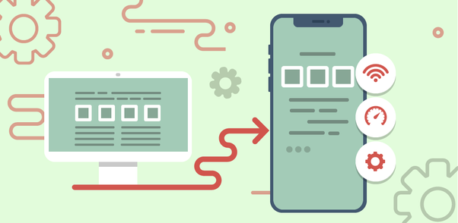

The architecture of mobile web apps:

## Web apps for mobile devices are designed to run on your mobile web browser. These are built using web technologies such as HTML5, CSS and JavaScript that are multiplatform. It is therefore safe to consider HTML5 as the technology of choice for mobile web app development.

## Hybrid apps:

Desktop and mobile web application mixtures are hybrid applications. Like native apps, they live in an app store, and can take advantage of many available devices. They depend on HTML being made in a browser, unlike web apps, with the exception of embedding in the app. These are constructed using HTML, CSS, JavaScript, JQuery, mobile, Cordova/phone gap frameworks, etc.

## Examples of hybrid apps:



## Progressive web apps:

Progressive web apps are like regular websites, but provide additional user features such as offline service and computer hardware access that were previously only accessible from local websites for mobile apps.

# Bibliography:

* <https://www.computerhope.com/jargon/m/memory.htm>
* https://www.tutorialspoint.com/computer_fundamentals/computer_cpu.htm
* <https://www.computertechreviews.com/definition/ram-random-access-memory>
* <https://www.slideshare.net/geeksagar/primary-memory-ram-rom-and-their-types?qid=c6406a29-bc02-4da8-84bd-fdc61ef58616&v=&b=&from_search=1>
* <https://www.techopedia.com/definition/25597/computer-network>
* <https://www.javatpoint.com/types-of-computer-network>
* <https://www.techopedia.com/definition/16955/network-infrastructure>
* <https://blog.netwrix.com/2019/01/08/network-devices-explained/>
* <https://study.com/academy/lesson/what-is-an-input-device-for-a-computer-definition-examples-quiz.html>
* <https://peda.net/kenya/ass/subjects2/computer-studies/form-1/the-computer-system>
* <https://whatis.techtarget.com/definition/operating-system-OS>
* <https://squareboat.com/blog/different-types-of-software-with-examples>
* <https://techterms.com/definition/web_application>
* <https://en.yeeply.com/blog/6-different-kinds-web-app-development/>
* <https://www.techopedia.com/definition/2953/mobile-application-mobile-app>
* <https://whatis.techtarget.com/definition/supercomputer>
* <https://www.whoishostingthis.com/blog/2016/08/12/supercomputers/>
* <https://www.explainthatstuff.com/how-supercomputers-work.htm>
* <https://www.tutorialspoint.com/computer_fundamentals/computer_cpu.htm>
* <http://newbibang.blogspot.com/2016/04/definition-and-function-computer-ram.html>